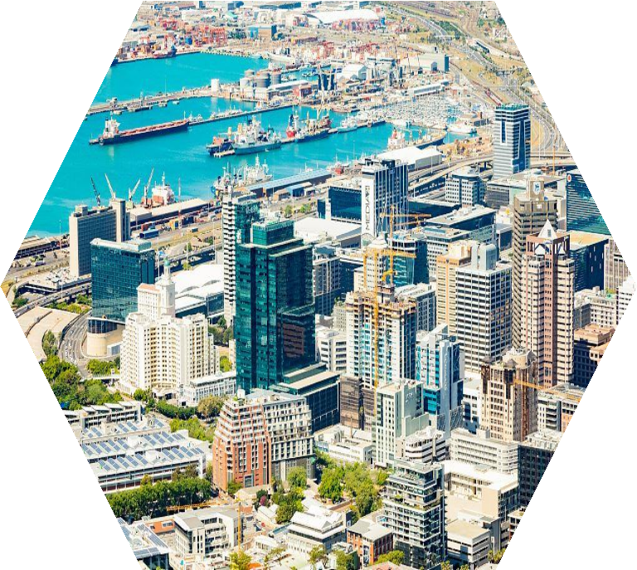

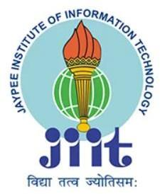

**South Africa’s**

**Development**

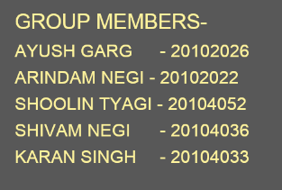

**Demographic Profile**

South Africa’s youthful population is gradually aging, as the country’s total fertility rate (TFR) has declined dramatically from about 6 children per woman in the 1960s to roughly 2.2 in 2014. This pattern is similar to fertility trends in South Asia, the Middle East, and North Africa, and sets South Africa apart from the rest of Sub-Saharan Africa, where the average TFR remains higher than other regions of the world. Today, South Africa’s decreasing number of reproductive age women is having fewer children, as women increase their educational attainment, workforce participation, and use of family planning methods; delay marriage; and opt for smaller families.

As the proportion of working-age South Africans has grown relative to children and the elderly, South Africa has been unable to achieve a demographic dividend because persistent high unemployment and the prevalence of HIV/AIDs have created a larger-than-normal dependent population. HIV/AIDS was also responsible for South Africa’s average life expectancy plunging to less than 43 years in 2008; it has rebounded to 63 years as of 2017. HIV/AIDS continues to be a serious public health threat, although awareness-raising campaigns and the wider availability of anti-retroviral drugs is stabilizing the number of new cases, enabling infected individuals to live longer, healthier lives, and reducing mother-child transmissions.

Migration to South Africa began in the second half of the 17th century when traders from the Dutch East India Company settled in the Cape and started using slaves from South and southeast Asia (mainly from India but also from present-day Indonesia, Bangladesh, Sri Lanka, and Malaysia) and southeast Africa (Madagascar and Mozambique) as farm laborers and, to a lesser extent, as domestic servants

n the late 19th century and nearly the entire 20th century, South Africa’s then British colonies’ and Dutch states’ enforced selective immigration policies that welcomed "assimilable" white Europeans as permanent residents but excluded or restricted other immigrants. Following the Union of South Africa’s passage of a law in 1913 prohibiting Asian and other non-white immigrants and its elimination of the indenture system in 1917, temporary African contract laborers from neighboring countries became the dominant source of labor in the burgeoning mining industries. Fewer African labor migrants were issued temporary work permits and,

instead, increasingly entered South Africa with visitors’ permits or came illegally, which drove growth in cross-border trade and the informal job market. A new wave of Asian immigrants hasalso arrived over the last two decades, many operating small retail businesses, poor services, and a reduced quality of life. The 2002 Immigration Act and later amendments were intended to facilitate the temporary migration of skilled foreign labor to fill labor shortages, but instead the legislation continues to create regulatory obstacles. Although the education system has improved and brain drain has slowed in the wake of the 2008 global financial crisis, South Africa continues to face skills shortages in several key sectors, such as health care and technology.

Some estimated parameters of south Africa’s demographic profile according to the surveys are as follows🡪

Population 🡪56,978,635 (July 2021 est.)

Ethnic groups 🡪Black African 80.9%, Colored 8.8%, White 7.8%, Indian/Asian 2.5%

(2018 est.)

Age structure 🡪0-14 years: 27.94% (male 7,894,742/female 7,883,266)

15-24 years: 16.8% (male 4,680,587/female 4,804,337)

25-54 years: 42.37% (male 12,099,441/female 11,825,193)

55-64 years: 6.8% (male 1,782,902/female 2,056,988)

65 years and over: 6.09% (male 1,443,956/female 1,992,205) (2020

est.)

Population growth rate 🡪0.95% (2021 est.)

Infant mortality rate 🡪total: 26.82 deaths/1,000 live births

male: 29.9 deaths/1,000 live births

female: 23.68 deaths/1,000 live births (2021 est.) Education expenditure 🡪6.5% of GDP (2019)

.

SOUTH AFRICA’S DEVELOPMENT PLAN

**South Africa Health Policy**

**Overview**

Healthcare in South Africa is administered by the Department of Health. However, South Africa does not have a system of universal healthcare. Instead, it has two parallel systems. A private healthcare system and a public healthcare system operate in tandem with one another.

The majority of the public, up to 80% of the population, relies on the public system for their care. The public system is subsidized by the government. In general, it is underfunded and poorly managed. There are more than 400 public hospitals in South Africa. Large, regional hospitals are managed by provincial health departments. Smaller hospitals and primary care clinics are managed at the municipal level.

On the other side, an estimated 80% of doctors work in the private system, serving just 20% or so of the population, primarily middle class and upper-class families, as well as expats. As such, the public system is constantly short of resources, while the private system is very strong.

**Cost Of Healthcare**

South African public healthcare is funded by the government by taxation, as well as through point-of-care spending from patients.

Public healthcare in South Africa is subsidized by up to 40%. The system uses the Uniform Patient Fee Schedule or UPFS to regulate patient billings and physician payments. Patient charges are based on income and family size and the UPFS uses three categories of patients to determine the cost of different visits and procedures.

Full paying patients are either being treated by a private physician, are externally funded, or are non-citizens. This would apply to expats, who are eligible to use public facilities but must pay the highest billing category.

Partially subsidized patients are eligible to have the cost of their care partially covered on the basis of their income. Finally, fully subsidized patients are those who are referred to a hospital by the Primary Healthcare Services. This mostly applies to people who have a lower income.

Additionally, there are also some occasions in which certain medical services are free. For instance, there are nearly 3,500 clinics that provide free healthcare to pregnant women and children under the age of six.

**Notable Health Policies**

* **The National Health Insurance**

To ameliorate the lack of quality and access to care, the government plans to establish the National Health Insurance in 2026. It intends to ensure access to all citizens and residents of South Africa to quality health services provided by both the public and private sector, regardless of socioeconomic status. It would be social health insurance in that it enforces contributions from employers and employees to partially fund the system. South Africans would have federal government-sponsored plans to choose from that will pay directly for health services from all providers. The aim of the program is to encourage the wealthiest to pay into the public system and incentivize them to use public health services.

* **National Adolescent and Youth Health Policy**

This Adolescent and Youth Health Policy aims to promote the health and wellbeing of young people, aged 10-24 years. The mission of this policy is to improve the health status of young people through the prevention of illness, the promotion of healthy lifestyles, and the improvement of the health care delivery system by focusing on the accessibility, efficiency, quality, and sustainability of adolescent and youth friendly health services (AYFS).

Ultimate goal is to provide guidance to departments and organizations working with the Department of Health on how to respond to the health needs of young people. This requires an integrated approach that is not just problem-oriented, but with focus on promotion of healthy life-styles, mitigation of risk factors and puts in place ‘safety nets’ for prevention, early detection and intervention.

* **National Health Laboratory Service**

The National Health Laboratory Service was established in terms of the National Health Laboratory Service Act of 2000. The entity operates more than 230 laboratories in nine provinces and is the sole provider of training for pathologists and medical scientists, provides comprehensive and affordable pathology services to more than 80% of the South African population, and plays a significant role in the diagnosis and monitoring of HIV and TB. Over the medium term, the entity will continue to focus on providing laboratory testing services to healthcare providers mainly in the public sector, and expanding its provisions in response to increased demand for its services in priority programmes such as HIV and TB care. The COVID‐19 pandemic has had a negative impact on overall testing in that fewer patients sought care at health facilities during lockdown, resulting in a 12% decrease in tests conducted from 2019/20 to 2020/21. However, as at 20 January 2021, the entity had conducted an estimated 3.3 million COVID‐19 tests.

**Eminent Health Authorities and their functionalities**

* **The Compensation Commissioner for Occupational Diseases in Mines and Works**

It was established in terms of the Occupational Diseases in Mines and Works Act of 1973. The act gives the commissioner the mandate to collect levies from controlled mines and works; compensate workers, former workers and the dependents of deceased workers in controlled mines and works that have developed occupational diseases in their cardiorespiratory organs; and reimburse workers for any loss of earnings while being treated for TB. Over the medium term, the commissioner was expected to focus on improving access to services provided to current and former mineworkers, increasing the number for claims paid, and fast‐tracking the claims management process. The payment of claims is funded through levies collected from controlled mines and works on behalf of their employees. These funds are used to compensate current and former mine workers for diseases for which they are entitled to receive compensation.

* **The Council for Medical Schemes**

It is a regulatory authority designated in terms of the Medical Schemes Act of 1998 to oversee the medical schemes industry. The Act sets out the functions of the council, which include protecting the interests of beneficiaries, controlling and coordinating the functions of medical schemes, collecting and distributing information about private healthcare, and advising the Minister of Health on matters concerning medical schemes. Over the medium term, the council was expected to ensure the efficient and effective regulation of the medical schemes industry, and support the department in its efforts to achieve universal health coverage for all South Africans through national health insurance. The council aimed to achieve this by developing and implementing the guidance framework for low‐cost benefit options, and finalizing proposals for the Medical Schemes Amendment Bill and the health market inquiry.

**Tax Policy**

Economic growth can be defined as the annual rate increase in total production or income in the economy. Taxes are a proportion of income or consumption of a country’s population. This led to many studies aiming to determine whether there is a long run relationship between economic growth and taxation.

All developing countries face difficult problems in trying to marshal limited resources to promote economic growth. Few face a combination of problems as challenging as those confronting South Africa. Economic constraints are conjoined with the political legacy of apartheid. The democratically elected governments that took office in 1994 and 1999 have managed, with quite limited resources, to preserve a remarkable measure of political cohesion and to bring South Africa relatively unscathed through the Asian economic turmoil that threatened to spread to other developing nations. While it will take more than a little good luck to surmount the challenges South Africa faces, current auguries are hopeful.

Though the democratically elected government has modestly changed the tax laws, the current tax regime is not fundamentally different from the system inherited from the apartheid years

Because income inequality is extreme, all personal income tax and most revenue is collected from a small proportion of the population. The yield of the current system—more than one-fourth of GDP—means that tax policymakers must reform a vigorously functioning tax system and not design a new system, starting from a blank slate. As a result, they must take careful account of existing tax rules, contractual obligations, and transition problems.

The South African economy has experienced a significant transformation since the advent of democracy. South Africa has achieved an average rate of economic growth of 3.3% per year in real terms over the period 1994 to 2012, an exceptional improvement on the average annual growth of 1.4% during the period 1980 to 1993 (Industrial Development Corporation, 2013). However, the pace of growth fell somewhat short of the 3.6% average recorded by the world economy (Industrial Development Corporation, 2013). In the 2014 and 2015 fiscal year tax revenue that was collected amounted to R986.3 billion and grew by R86.3 billion (9.6%), this growth was supported by personal income tax and value added tax which grew by 13.9% and 9.9% respectively (South African Revenue Service, 2015). The gross domestic product of South Africa by 2012 was 77% larger in real terms relative to 1994. It is realized that since the advent of democracy in South Africa, tax revenue and economic growth have been experiencing an upward growth trajectory in absolute terms

Taxation may involve payments to a minimum of two different levels of government: central government through SARS or to local government..Prior to 2001 the South African tax system was "source-based", where income is taxed in the country where it originates. Since January 2001, the tax system was changed to "residence-based" wherein taxpayers residing in South Africa are taxed on their income irrespective of its source. Non residents are only subject to domestic taxes.

Revenues as a share of GDP for major tax types of central government, South Africa, 1993/84-2007/08 shown in Table :

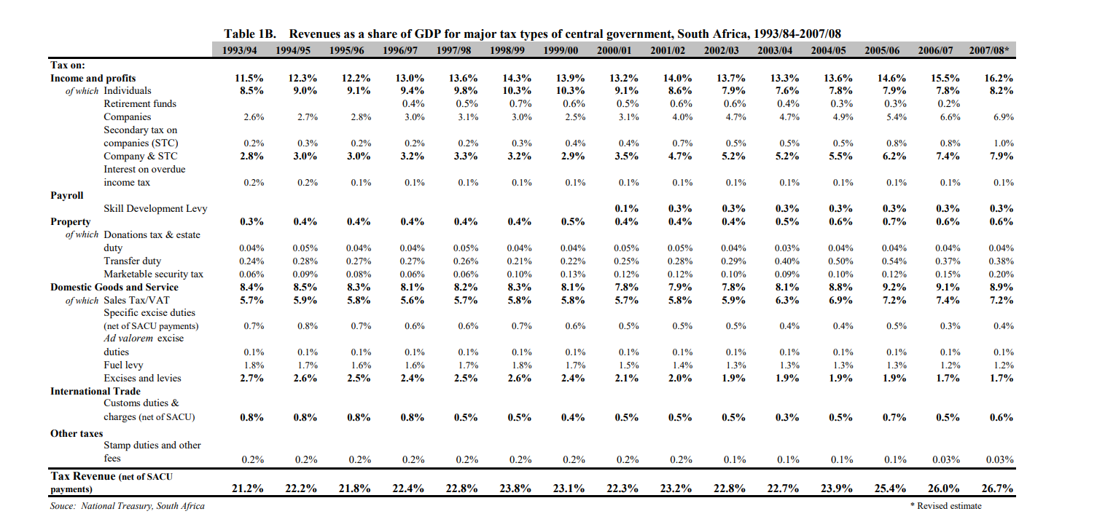

Central government revenues come primarily from income tax, value added tax (VAT) and corporation tax. Local government revenues come primarily from grants from central government funds and municipal taxes.

In 2018/19 financial year, South Africa had a tax-to-GDP ratio of 26.2% that was only slightly more than the 25.9% in 2017/18

South Africa uses its fiscal instruments to significantly reduce market income inequality and poverty through a progressive tax system and highly progressive social spending. The rich bear the brunt of taxes, and the government redirects these resources to the poorest in society to raise their incomes. Despite the large fiscal redistribution, however, South Africa remains one of the most unequal countries in the world.

The tax policy challenges facing South Africa are intellectually fascinating, but finding a way to meet them is much more than interesting: it is vital to the success of South Africa’s efforts to sustain a multiracial democracy. The black and colored majority’s forbearance from extracting vengeance for the feral oppression they endured at the hands of the white minority is impressive and humbling. But forbearance cannot endure if the lot of the once- disenfranchised population fails to improve. Given low average incomes, such improvement cannot come in a politically and economically sustainable way from redistribution, but must flow from sustained and broadly based economic growth

**Federal Structure**

The Republic of South Africa is a parliamentary republic with three-tier system of government and an independent judiciary, operating in a parliamentary system. Legislative authority is held by the Parliament of South Africa.

Executive authority is vested in the President of South Africa who is head of state and head of government, and his Cabinet.

The President is elected by the Parliament to serve a fixed term.

South Africa's government differs greatly from those of other Commonwealth nations. The national, provincial and local levels of government all have legislative and executive authority in their own spheres and are defined in the South African Constitution as "distinctive, interdependent and interrelated".

Operating at both national and provincial levels ("spheres") are advisory bodies drawn from South Africa's traditional leaders. It is a stated intention in the Constitution that the country be run on a system of co-operative governance.

The national government is composed of three inter-connected branches:

* Legislative
* Executive
* Judicial

**Legislative**

The Parliament of the Republic of South Africa is South Africa's legislature; under the present Constitution of South Africa, the bicameral Parliament comprises a National Assembly and a National Council of Provinces. The current twenty-seventh Parliament was first convened on 22 May 2019.

From 1910 to 1994, members of Parliament were elected chiefly by the South African white minority. The first elections with universal suffrage were held in 1994.

Both chambers held their meetings in the Houses of Parliament, Cape Town that were built 1875–1884. A fire broke out within the buildings in early January 2022, destroying the session room of the National Assembly. The National Assembly will temporarily meet at the Good Hope Chamber.

**Executive**

The President, Deputy President and the Ministers make up the executive branch of the national government. Ministers are Members of Parliament who are appointed by the President to head the various departments of the national government. The president is elected by parliament from its members.

**Judicial**

The third branch of the national government is an independent judiciary. The judicial branch interprets the laws, using as a basis the laws as enacted and explanatory statements made in the Legislature during the enactment. The legal system is based on Roman-Dutch law and English common law and accepts compulsory ICJ jurisdiction, with reservations. The constitution's bill of rights provides for due process including the right to a fair, public trial within a reasonable time.

**Provincial Government**

The nine provinces of South Africa are governed by provincial governments which form the second layer of government, between the national government and the municipalities. The provincial governments are established, and their structure defined, by Chapter Six of the Constitution of South Africa.

The provincial governments are structured according to a parliamentary system in which the executive is dependent on and accountable to the legislature. In each province the provincial legislature is directly elected by proportional representation, and the legislature in turn elects one of its members as Premier to head the executive. The Premier appoints an Executive Council (a cabinet), consisting of members of the legislature, to administer the various departments of the provincial administration.

The powers of the provincial governments are circumscribed by the national constitution, which limits them to certain listed "functional areas". In some areas the provincial governments' powers are concurrent with those of the national government, while in other areas the provincial governments have exclusive powers. The constitution prescribes a principle of "co-operative government" whereby the various layers of government must co-ordinate their actions and legislation; it also lays down a series of rules for resolving conflicts between national and provincial legislation.

**Local Government**

Local government in South Africa consists of municipalities of various types. The largest metropolitan areas are governed by metropolitan municipalities, while the rest of the country is divided into district municipalities, each of which consists of several local municipalities. After the municipal election of 18 May 2011 there were eight metropolitan municipalities, 44 district municipalities and 226 local municipalities.

Municipalities are governed by municipal councils which are elected every five years. The councils of metropolitan and local municipalities are elected by a system of mixed-member proportional representation, while the councils of district municipalities are partly elected by proportional representation and partly appointed by the councils of the constituent local municipalities.